5.108: (a) One way of looking at this is that the apparent weight, which is the same as the upward force on the person, is the actual weight of the person minus the centripetal force needed to keep him moving in its circular path:
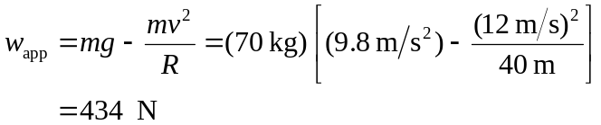
(b) The cart will lose contact with the surface when its apparent weight is zero; i.e., when the road no longer has to exert any upward force on it:
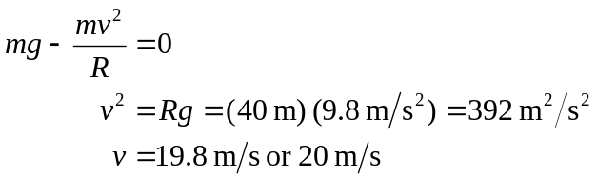
The answer doesn’t depend on the cart’s mass, because the centripetal force needed to hold it on the road is proportional to its mass and so is its weight, which provides the centripetal force in this situation.

